The Asian American Education Project
K-12 Professional Development Workshop
Partner Toolkit

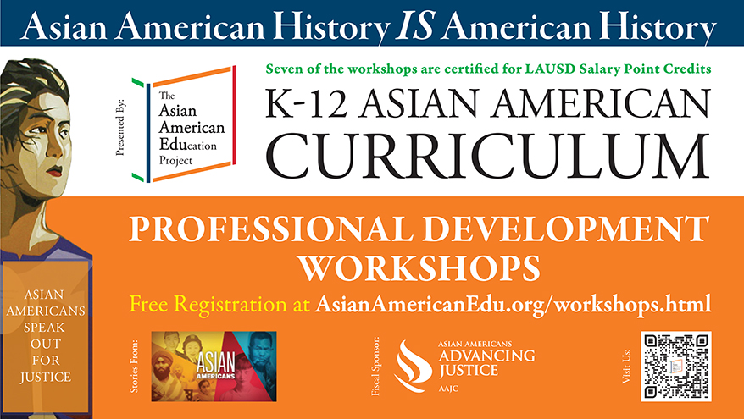

Suggested Tweet:
The Asian American Education Project is offering FREE K-12 curriculum workshops.
Register here. @AAAJ_AAJC fiscal sponsor

In light of recent events, this curriculum is more important than ever. Join us & learn more today!
#AAPI #EdChat #StopAAPIHate #StopAsianHate

(tag/message influencers to help retweet it)

Suggested Copy for Facebook and Instagram:
The Asian American Education Project is offering FREE K-12 curriculum workshops. Each workshop covers a theme significant to the Asian American and Pacific Islander community, #AAPI, including anti-Asian hate, citizenship, civil rights, identity, immigration, and racism.
Join us to learn about how Asian immigrants have contributed and shaped the way the country is today since their arrival as far back as the 1800s. From labor activism to fighting for school integration and citizenship rights in the courts, and against model minority, perpetual foreigner stereotypes and anti-Asian hate, this one of the fastest-growing populations has faced adversity, and fought for opportunities to create roots here in the U.S.
Sign up for workshops here.

Suggested E-mail:
Subject: Telling the AAPI Stories: Sign Up for Free K-12 Professional Development Workshops
Asian American and Pacific Islander history is American history, but is often left out of curriculum in K-12 schools. Asian Americans Advancing Justice | AAJC, fiscal sponsor of The Asian American Education Project is announcing a series of free workshops for K-12 teachers designed to promote the inclusion of historically and culturally competent curriculum about Asian Americans and Pacific Islanders (AAPIs) nationwide.
K-12 Asian American Curriculum Professional Development Workshops start on April 18. In this series of virtual workshops, The Asian American Education Project will be showcasing curriculum on the AAPI experience. It is divided into themes to make it easier for educators to adapt the whole or part of the curriculum into their own practice. The workshop participants will:
- Learn more about some of the content of each thematic unit
- Learn how to navigate the website
- Be able to apply the curriculum into their teaching practice
Educators will learn about how Asian immigrants have contributed and shaped the way the country is today since their arrival as far back as the 1800s. From labor activism to fighting for school integration and citizenship rights in the courts, and against model minority, perpetual foreigner stereotypes and anti-Asian hate, this one of the fastest-growing populations has faced adversity, and fought for opportunities to create roots here in the U.S.
Help us spread the word to provide a more inclusive curriculum to schools nationwide.

Sign up for workshops or spread the word!

The lesson plans are developed in partnership with UCLA Asian American Studies Center and PBS LearningMedia. The thematic units were created by Waka Takahashi Brown, Curriculum Specialist, Stanford Program on International and Cross-Cultural Education (SPICE) with our lesson plans.

