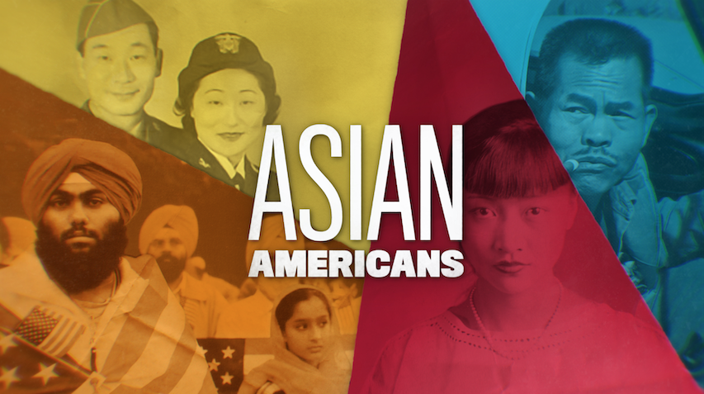

TOPIC: Generation Rising, APIDAs Contribute

GRADES: 6-12

BACKGROUND ESSAY
During the 1970s, arts and culture became vehicles for elevating the narratives of Asian Americans, a term first used in 1968 during the struggle to establish ethnic studies at California universities. Under this new pan-Asian identity, a generation of young Asian American organizers, academics, and artists emerged, ready to define themselves and their history to the rest of America.

Actors, musicians, artists, writers, and filmmakers helped to increase the visibility of Asian American identities and cultures across various media. In the late 1960s, the East West Players—the oldest and largest Asian American theatre company in the U.S.—was formed in Los Angeles in a church basement. The plays encapsulated both Asian and Asian American experiences, including the incarceration of Japanese Americans and immigration stories of Angel Island. The stories captivated and educated multiracial audiences. These Asian American playwrights and actors paved the way for today’s successful actors.

In 1970, Chris Kando Ijima, Noboku Joanne Miyamoto, and William “Charlie” Chin formed a folk band to share their music on the Asian American experience at venues across the country. The trio met at a conference for Asian American activists and student organizations at Pace College in New York City. Their 1973 recording, A Grain of Sand: Music for the Struggle by Asians in America, is considered the first album of Asian American music.

In the following years, Asian Americans would create ground-breaking work in the arts. In 1976, author Maxine Hong Kingston published her memoir, The Woman Warrior: Memoirs of a Girlhood among Ghosts. Woman Warrior would later become essential class readings in Asian American and ethnic studies courses, and establish the category of Asian American literature. In the film world, director Wayne Wang’s noir Chan Is Missing (1982) explores Chinese American identity and is one of the first successful and acclaimed Asian American narrative feature films beyond the Asian American community. Wang would later direct the film adaptation of author Amy Tan’s best-selling 1989 debut novel, The Joy Luck Club. The film, a 1993 box office success, was the first major studio production to star an all-Asian cast since 1961’s Flower Drum Song.

Arts and culture can serve as catalysts in propelling movements forward. The arts reflected the spirit of and supported the Asian American Movement in the fight for social and racial justice, ethnic studies, and visibility.

VOCABULARY
- Asian American Movement: A grassroots movement from the late 1960s to 1980s that included the fight for ethnic studies at California universities and the creation of community programs, arts, music, literature, and other works by Asian Americans.

DISCUSSION QUESTIONS
- How does art and culture shape identity?
- Do art and culture have the power to affect history?
- How might art and culture build communities and contribute to social or political movements?
- In what ways can art connect present generations to past generations?

ACTIVITIES
Activity 1: A Grain of Sand
After watching the video and reading the background essay, students will analyze the lyrics of “We Are The Children” by A Grain of Sand (words and music by Iijima-Miyamoto).

Pass out copies of the song lyrics to “We Are the Children,” available from the liner notes from A Grain of Sand: Music for the Struggle of Asians in America at Smithsonian Folkways.

Play a recording of the song, also on Smithsonian Folkways. Direct the students to follow along as they listen to the song. Then, read the song lyrics aloud. Teachers may wish to read it aloud or ask for volunteers. During the read-aloud, prompt the students to circle any unknown words or references. Clarify and discuss any of these phrases or words.

After listening to and reading the lyrics, the students should take a few minutes to reflect on these questions:

- What did you notice about the song? What phrases or words stood out to you?
- What questions do you have about the song?
- What connections can you make between this song and your life, other school subjects, or events in the world?

Prompt students to turn to a partner and share their reflections. If time permits, ask students to share their ideas with the entire class.

Resources for Activity:

- Iijima, Chris Kando, Nobuko Miyamoto, "Charlie" Chin. A Grain of Sand: Music for the Struggle by Asians in America. Smithsonian Folkways Recordings, 1973.

Activity 2: Art & Culture
Begin the activity by noting that other prominent artists that emerged during the 1970s including Duane Kubo (a filmmaker), Robert Nakamura (filmmaker), Nam June Paik (visual art), and Lawson Inada (poetry).
Give students a choice to examine one Asian American artist. Assign students one of the following artists and ask them to research and get to know one item of their art that they’ll reflect on. Students will also plan their own original responses to the work of art.
Artists to assign to the class:
- Lawson Inada, poet
- Nam June Paik, visual artist
- Duane Kubo, film
- Chris Kando Iijima, folk artist
- Nobuko JoAnne Miyamoto, folk artist
- Leland Wong, graphic artist
- Frank Chin, playwright
- Masumi Hayashi, photographer and artist
In a journal or on a piece of paper, ask students to make the following observations about their selected piece of art:

- “The art gives flesh and blood to the politics,” says Noboku Joanne Miyamoto in the video clip. What does that mean? How is that fitting in regards to your assigned artist?
- What did you notice about the art, film, or poem? What phrases or words stood out to you?
- What questions do you have for the artist?
- What connections can you make between this piece of art and your life, other school subjects, or events in the world?

Next, have students select an artistic medium (print, song, video, graphic representation) to create their own original work that represents their culture, identity, family, or their generation:
Once students have enough time to create a piece of art in response, tell them that they will exhibit their works to their classmates. Give students a piece of tape and ask them to create a “Gallery Wall” of their creations around the room. Pass out a stack of sticky notes. As they wander around the room, they should write and post a comment next to their peers’ circles. Remind students that the sticky notes should be positive, express appreciation, or give a comment. Some sentence starters for the sticky notes might include:
- “I like how…”
- “I also…”
- “This connected with me because…”
- “I notice how…”
After students have a chance to wander around the gallery and post comments, gather again as a whole group. Ask them to share aloud some reflections: What did you notice about all of the creations? What did you learn about yourself from the activity? About others?

FURTHER INFORMATION
- Chinese American Exclusion/Inclusion. (n.d.). Chinese Historical Society of America.
- “A Grain of Sand: Music for the Struggle by Asians in America,” Smithsonian Folkways Recordings

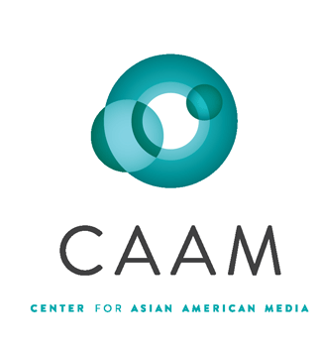
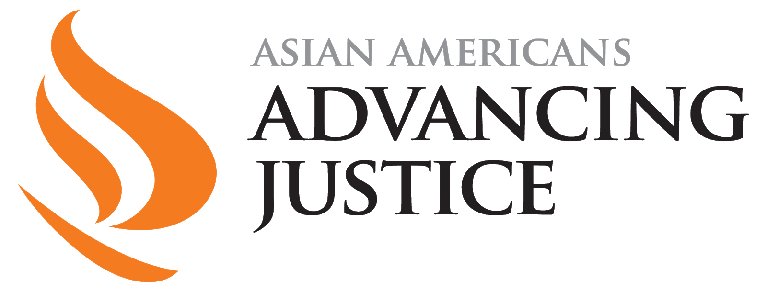

PBSLearningMedia.org/collection/asian-americans-pbs

Major funding for Asian Americans is provided by Wallace H. Coulter Foundation; Corporation for Public Broadcasting (CPB); Public Broadcasting Service (PBS); Ford Foundation/JustFilms; National Endowment for the Humanities; The Freeman Foundation; The Arthur Vining Davis Foundations; Carnegie Corporation of New York; Kay Family Foundation; Long Family Foundation; Spring Wang; and California Humanities.

