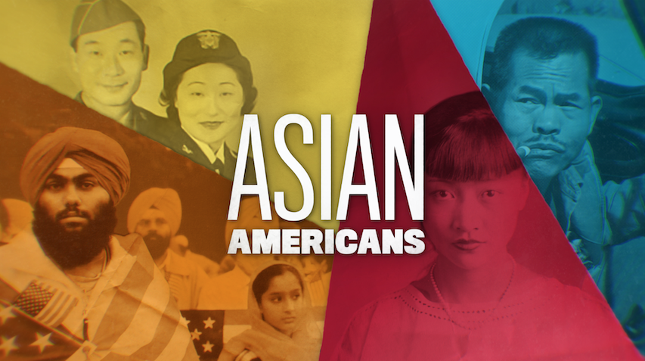

**TOPIC: Who Defines Loyalty?: Japanese Americans During World War II**

**GRADES: 9-12**

**BACKGROUND ESSAY**

Approximately 120,000 Japanese Americans were incarcerated in camps for over three years during World War II. While imprisoned by their own government, Japanese Americans expressed varying reactions to tests of their loyalty to the United States.

In the camps, all prisoners were required to complete what is commonly referred to as a “loyalty questionnaire.”This controversial questionnaire was aimed at Nisei—the adult children of Japanese immigrants who were born with American citizenship—to assess whether these prisoners could “safely” relocate outside of the camps, and was used to help the War Department recruit Nisei men and women into military service. To this end, Question 27 asked if Nisei men would serve on U.S. combat duty; alternatively, women were asked if they would serve, in some cases, in the Women’s Army Auxiliary Corps. Question 28 asked if Japanese Americans would “renounce” allegiance to Japan.

As might be expected, incarcerees were greatly troubled by the questionnaire. Questions 27 and 28 caused division within camps and families. Japanese Americans, born in the U.S., resented being asked to renounce loyalty to Japan, a country to which they may have had little connection. Issei—Japanese-born immigrants—found the questions to be especially challenging. The Issei were legally barred from becoming U.S. citizens by the 1790 Naturalization Act, which limited citizenship for immigrants to white people. So, if Issei renounced loyalty to Japan, they might become stateless. Families were concerned about being split up in a system of prisons: If a person responded “no” to any of the two questions, they were labeled disloyal, “no-nos” and sent to Tule Lake, a segregated detention center with harsher conditions. The label of a “no-no” remained divisive in the Japanese American community for decades after World War II, with many former prisoners reporting rejection or shame from the status.

Some incarcerated Japanese Americans did respond to the call for military service. In fact, approximately 33,000 served in the U.S. Armed Forces during World War II. Nisei men who responded “yes” to questionnaires were drafted into a racially segregated military unit, the 442nd Regimental Combat Team, in which approximately 2,700 Japanese American soldiers from the mainland and Hawaii served in battlefronts in Europe. Despite facing harsh treatment by both the public and their military peers, the battalion today is recognized for shifting the military and public view of Japanese Americans as “loyal” Americans. For their valor and bravery, the 442nd is recognized as the most decorated combat team in U.S. history.

There were those who expressed resistance to the questionnaire, with individuals and civil rights organizations that challenged the incarceration of Japanese Americans on constitutional grounds. Fred Korematsu, Gordon Hirabayashi, and Minoru Yasui were among the Japanese Americans who stood up to their imprisonment. Fred Korematsu defied the order to be moved into prison camps. He argued that the removal violated his civil liberties. Both Hirabayashi and Yasui resisted curfew orders as an act of civil disobedience, stating the curfew law and exclusion were unconstitutional. All of their convictions were upheld by the U.S. Supreme Court although they were widely criticized by many civil libertarians at the time. Eventually in the 1980s, the cases were overturned in federal courts. Korematsu, Hirabayashi, and Yasui were key to receiving an apology and reparations from the U.S. government in 1988. They pursued a lifelong legal battle to oppose the unjust acts held against Japanese Americans. The memory of their fight for justice continues to thrive today.

**VOCABULARY**

* **Battalion**: A group of soldiers
* **Civil disobedience:** Refusal to obey laws as a way of forcing the government to do or change something
* **Incarceree**: Someone who is imprisoned
* **Issei:** Japanese people living in the United States but who were born in Japan
* **Nisei:** The sons and daughters of the people who immigrated from Japan to the United States
* **Profiling:** Regarding some people as more likely to commit crimes because of their appearance, race, etc.
* **Renounce**: To refuse; to not acknowledge
* **Reparations**: Making up for a past wrongful act, sometimes with money or another way
* **Segregated**: To separate people because of their race, religion, or another marker of their identity
* **Stateless**: Someone who is not a citizen of any country

**DISCUSSION QUESTIONS**

* What does loyalty mean to you in your personal life?
* What is a loyal citizen? How about a disloyal citizen?
* What consequences resulted from the U.S. government’s emphasis on loyalty? What impact did the questionnaire have on individuals and communities?
* If the U.S. government was concerned about the loyalty of certain minority groups, why do you think the Wartime Department allowed Japanese Americans to join the military?
* What might have driven some Japanese Americans to serve in the military in groups like the 442nd? Did serving in the military help them “prove” their loyalty?
* In your opinion, how much should we value loyalty from citizens?

**ACTIVITIES**

**Activity 1: Defining Loyalty**

Tell students that they will be doing a “fishbowl”-style discussion, in which they consider different perspectives based on the populations listed below in regards to the Loyalty Questionnaire. To prepare for the discussion, place students into groups of 4-5, and assign each group one of the following:

* **Issei** / Japanese-born people, imprisoned in the camps
* **Nisei Males** / U.S-born children of Japanese immigrants, who replied “yes” to military recruitment
* **Nisei Women** / U.S-born children of Japanese immigrants
* **“No-nos” /** Japanese American prisoners who answered “no” to one or more of Questions 27 and 28

After assigning a population, ask students to prepare for the discussion by doing research on the “Statement of United States Citizen of Japanese Ancestry” or more widely known as the “Loyalty Questionnaire.” Students should make note of the following, from their assigned perspective:

|  |  |
| --- | --- |
| **Research Topic** | **Notes or Questions** |
| What did you notice about the Loyalty Questionnaire document? |  |
| How would you respond to this document from your assigned perspective? |  |
| What would influence your decision? |  |
| What questions might you ask of the other groups? |  |

*Directions for the Fishbowl Discussion:*

* Prepare for a fishbowl discussion by arranging the room into two concentric circles of desks or chairs:
  + In the **inner circle**, sit 3-5 students who discuss in the center of the room.
  + In the **outer circle**, the rest of the class sits and observes the inner circle’s discussion.
* Pass out small pieces of paper. Ask all students to write one or more of the questions they’ve prepared, one question per paper.
* Collect all of the questions.
* Assign a student in the “outer circle” to be a “Question Asker,” who chooses from the class’ questions to pose to the inner circle. Give them the set of questions.
* Ask one group to sit in the inner circle.
* Set a timer for 5-7 minutes.
* The Question Asker in the outer circle should begin with a question.
* For 5-7 minutes, the inner circle should discuss the question. The inner-circle should refer to their notes when answering a question, considering the perspective from which they were assigned. Inner circle participants are encouraged to ask each other questions and are free to follow-up or elaborate on what others say.
* Students in the outer circle are not allowed to speak. They listen and reflect on the discussion.
* When a group’s 5-7 minutes ends in the inner circle, switch to the next group.
* After each group has had a chance to sit in the inner circle, debrief the process:
  + What did you hear, as a member of the outer circle? What ideas were expressed?
  + What opportunities or challenges did you have in talking from your group’s perspective?
  + Overall, what observations do you have about the Loyalty Questionnaire?

**Activity 2: Racial Profiling**

Racial profiling is the suspicion of a person because of their racial appearance or background rather than because of actual evidence of wrongdoing. Racial profiling causes people to be targeted and punished over their physical appearance or their historical relationship to their community, even when there is no evidence that they have done anything wrong. Racial profiling relies on harmful stereotypes that are rooted in racism and discrimination.

During World War II, Japanese Americans were profiled based on their ethnicity. The U.S. government suspected that they might be disloyal to America and working for the Japanese government, even though there was no real evidence of espionage or sabotage. As a result of these suspicions, Japanese Americans were rounded up and forced into incarceration camps for years

Racial profiling is still a serious problem today. To connect this history to the present day, ask students to write a short reflection paper using the following prompt:

*Pick one contemporary example of racial profiling. Analyze the contemporary example using the incarceration of Japanese Americans as a case study by comparing and contrasting this contemporary example with what happened to Japanese Americans during World War II.*

If students have trouble thinking of contemporary examples of racial profiling, you may provide the following list as a starting point:

* Racial profiling of Black people as criminals
* Racial profiling of Latinx people as undocumented immigrants
* Racial profiling of Asian people as infecting others with COVID-19
* Racial profiling of Arab or South Asian people as terrorists

For example, in the case of racial profiling of Asian people as infecting others with COVID-19, students might consider:

* **Targeting**: What statistics show the rise of hate crimes against Asian and Pacific Islander Americans? What examples of hate crimes testify to their personal experiences with discrimination during the COVID-19 pandemic?
* **Lack of Due Process:** Are there any legal channels that Asian and Pacific Islanders have used to challenge profiling during COVID-19? What other channels have helped them express and challenge profiling?
* **Human Cost:** What effects might profiling have on this group? How does it hurt their everyday interactions and safety?
* **Solutions:** Can citizens counter such targeting? Can they donate to campaigns or causes? Creating arts or social media posts? What things that people are doing to challenge the profiling of Asian and Pacific Islanders?

Give students the following chart to help them structure their research:

|  |  |
| --- | --- |
| **Feature of Racial Profiling** | **Your Case Study** |
| **Targeting**  Japanese Americans were targeted as being disloyal based on their families’ countries of origin.  How are people in your current example being targeted? |  |
| **Lack of Due Process**  Japanese Americans were not given an opportunity to defend themselves. Instead, all of them were forced into incarceration.  In your current example, how do the racially profiled people lose their access to due process or their individual rights? |  |
| **Human Cost**  What is the human cost of racial profiling in your current example?  How does it hurt the targeted community? How does it hurt society as a whole? |  |
| **Solutions**  What are some ways citizens can intervene or resist racial profiling? |  |

Once students have had a chance to research and fill out the above chart, allow them an opportunity to share their case studies.

Tell them to present their most important points on a poster and be prepared to share them. Give students time to arrange their information on a piece of chart paper.

Then, allow them to be posted around the room or in a digital sharing space. Give time for students to view each poster and allow them to debrief:

* What similarities and differences do you see between the Japanese American incarceration and your contemporary case studies?
* What impact does racial profiling have on individuals?
* What interventions from citizens and government are necessary to prevent racial profiling?

**FURTHER INFORMATION**

* “[Hanashi Oral History Archives](http://www.goforbroke.org/learn/archives/index.php).” Go for Broke National Education Center, 2020.
* “[Korematsu v. United States (1944).](https://www.landmarkcases.org/cases/korematsu-v-united-states)” Landmark Cases of the U.S. Supreme Court, Street Law, Inc., 2020.
* “[Loyalty Questionnaire.](https://encyclopedia.densho.org/Loyalty_questionnaire)” Densho Encyclopedia, Densho, 2019.





[**PBSLearningMedia.org/collection/asian-americans-pbs**](https://www.pbslearningmedia.org/collection/asian-americans-pbs/)

Major funding for Asian Americans is provided by Wallace H. Coulter Foundation; Corporation for Public Broadcasting (CPB); Public Broadcasting Service (PBS); Ford Foundation/JustFilms; National Endowment for the Humanities; The Freeman Foundation; The Arthur Vining Davis Foundations; Carnegie Corporation of New York; Kay Family Foundation; Long Family Foundation; Spring Wang; and California Humanities.