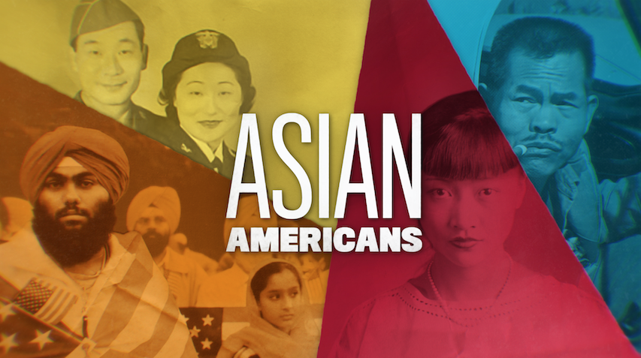

**TOPIC: Larry Itliong: Unity of Filipino and Mexican Farmworkers**

**GRADES: 6~~-~~12**

**BACKGROUND ESSAY**

After the Spanish-American War ended in 1898, the United States took possession of the Philippines, making it an American territory. In 1899, after fighting for independence from Spain, Filipinos waged a war for independence against the United States. The Philippine-American War ended in 1902 with the U.S. establishing civil government in the Philippines. The Philippine Independence Act established the Philippine Commonwealth with a 10-year transitional period from 1935 to 1945, thus paving the way for the Philippines to become independent from the United States in 1946.

From 1900 to 1934, Filipinos began immigrating to the California Central Valley, where there was a high demand for field laborers. Filipino immigrants, known as “Pinoys,” worked in the fields of the San Joaquin Valley, Salinas, and Sacramento. Another wave of Filipino immigration occurred after the passage of the Immigration Act of 1965.

Many Filipinos found themselves isolated from the rest of American society due to anti-Filipino racial incidents, housing discrimination and language barriers. Among male Filipino farmworkers, many remained single into old age due to U.S. anti-miscegenation laws, and are referred to as *“*manongs,*”* a term of respect for elderly Filipino men.

Without labor unions, migrant farmworkers were not being protected under existing labor laws. Living and working conditions were harsh and exploitative, including long hours, low wages, child labor, lack of workers’ rights such as pensions and healthcare, crowded living quarters, and non-functioning toilets.

In September 1965, Larry Itliong, a manong labor leader and co-founder of the Agricultural Workers Organizing Committee (AWOC), inspired Filipino farmworkers in Delano, California to initiate a strike against the grape farm owners. After they began striking, Itliong and other Filipino leaders such as Philip Vera Cruz, urged Mexican Americans to join Filipino farmworkers and fight for civil rights instead of being used as strikebreakers. Dolores Huerta and Cesar Chavez, civil rights leaders who had been organizing Mexican American farmworkers, were convinced by Filipino leaders to strike together. Thus, Filipinos and Mexican Americans formed the United Farm Workers (UFW), striking as one.

The Delano Grape Strike inspired people around the nation and Europe to support the farmworkers by boycotting grapes.The Grape Boycott continued for five years until July 1970 and led to the grape growers to agree to increase wages, contribute to union health plans, and provide protection from field pesticides. The joint Filipino and Mexican American effort would later lead to the passage of the California Agricultural Labor Relations Act of 1975, providing collective-bargaining powers for farmworkers state-wide.

Today, farmworkers still suffer from difficult living and working conditions including job hazards and instability, and continue to fight for labor rights.

**VOCABULARY**

* **Boycott**: protesting by refusing to purchase products or services
* **Anti-miscegenation laws**: laws implemented by many U.S. states that made it illegal for whites and people of color to engage in romantic relations or interracial marriage
* **Strike**: An organized protest when workers refuse to work in an effort to improve working conditions

**DISCUSSION QUESTIONS**

* Who were the manongs and what conditions in the United States contributed to the challenges of this community?
* Who initiated the Delano Grape Strike in 1965 and who inspired and led them to do this?
* What were the main reasons why farmworkers mobilized strikes against farm growers in central California during the mid-1960s?
* What was the United Farm Workers and why was it so important? How did this improve conditions for farmworkers?
* Why do you think Filipino leadership and participation in farmworker activism is often overlooked? Why is it important to recognize all diverse voices and participants in an event such as the farmworkers’ movement?

**ACTIVITIES**

***Activity 1: History of Filipino Immigration***

Many of the Filipinos who migrated and immigrated to the U.S. from the Philippines were farmworkers. Students will gain a background understanding of how Filipinos came to the United States.

Divide students up into groups of three to four and assign students to read the Background Essay.

Have each group research each of the following historical events between the United States and the Philippines and answer the accompanying question(s):

* **Treaty of Paris (1898)** – How did the U.S. come into possession of the Philippines? How did this lead to the large migration of Filipinos to fill agricultural jobs in California and Hawaii?
* **Philippine-American War (1899-1902**) – Why did Filipino revolutionaries fight against the U.S.? What was the result of the war?
* **Tydings-McDuffie Act (1934)** (also known as The Philippine Independence Act) – How did the Philippines eventually gain independence from the U.S.? How did this law change the status of Filipino immigration to the U.S.?

Conduct a class discussion on the following:

* How would you describe the relationship between the Philippines and the U.S.?
* How might this colonialist relationship affect the way Filipino Americans are viewed in the U.S.?

***Activity 2: Delano Grape Strike***

Instruct students to conduct detailed research from primary and secondary sources on the Delano Grape Strike. Have students answer the following questions. After, have students come back as a class and prepare to discuss and share their answers:

* Larry Itliong told his fellow farmworkers about the reality of going on strike that they would suffer a lot of hardship. They might get hungry, lose their car or their house. Why do think the farmworkers still voted to go on strike?
* How did grape growers counter the strike by Filipino American farmworkers?
* Who were Larry Itliong and Philip Vera Cruz? Describe the Agricultural Workers Organizing Committee and why it was formed..
* Who were Dolores Huerta and Cesar Chavez? Describe the National Farm Workers Association and why it was formed.
* How did the Filipino farmworkers convince Mexican American farmworkers to join their strike?
* What happened during the five-year-long strike and national grape boycott?
* What strengths did the solidarity between Filipino and Mexican American farmworkers bring to the overall labor and civil rights movement?

***Activity 3:******Farmworkers Today***

Tell students that they will look at present day farmworkers, many of whom are immigrants. As a class, we will explore the challenges they face while being an integral part of the American agricultural industry.

Ask students to address the four subjects and corresponding question/s below. Students should conduct research from high-quality sources as they relate to working conditions for today’s farmworkers. (examples may include: USDA, Bureau of Labor Statistics, National Agricultural Workers Survey, National Center for Farmworker Health).

* **Health Impacts of Working in Industrial Food Production**: What health risks and impacts are associated with agricultural labor?
* **Health Impacts on the Communities of Farmworkers**: What is the impact of poor housing conditions on farmworkers?
* **Farmworkers’ Barriers to Awareness and Improvement**: What are farmworkers legal protections? Do they have any? How are they protected? How are they not?
* **Improving Conditions for Farmworkers**: What are some suggestions for assisting immigrant workers? What type of policy reform might help?

Conduct a class discussion based on their research and have students share their findings.

**FURTHER INFORMATION**

* [“Author, Poet, and Worker: The World of Carlos Bulosan,”](https://content.lib.washington.edu/exhibits/bulosan/index.html) University of Washington Libraries.
* [“Fresh Fruit, Broken Bodies.”](https://matrix.berkeley.edu/research/fresh-fruit-broken-bodies) UC Berkeley Social Science Matrix.







[**PBSLearningMedia.org/collection/asian-americans-pbs**](https://www.pbslearningmedia.org/collection/asian-americans-pbs/)

Major funding for Asian Americans is provided by Wallace H. Coulter Foundation; Corporation for Public Broadcasting (CPB); Public Broadcasting Service (PBS); Ford Foundation/JustFilms; National Endowment for the Humanities; The Freeman Foundation; The Arthur Vining Davis Foundations; Carnegie Corporation of New York; Kay Family Foundation; Long Family Foundation; Spring Wang; and California Humanities.