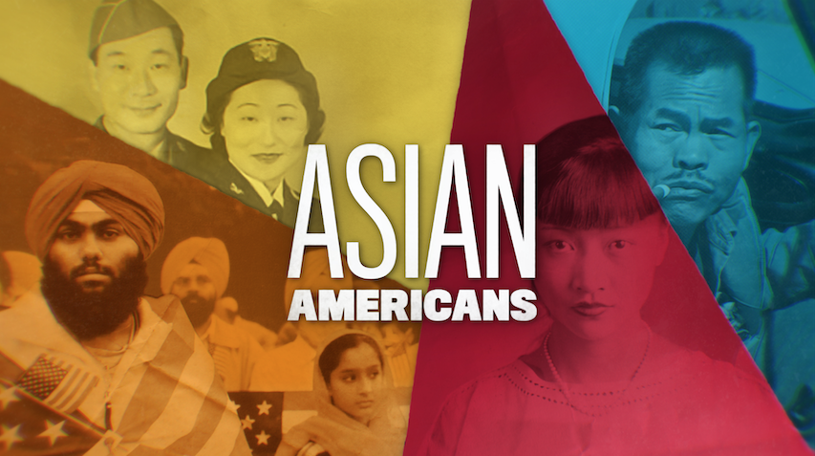

**TOPIC: McCarthyism**

**GRADES: 7 - 12**

**BACKGROUND ESSAY**

During the 1950s, the United States was gripped by fear of the Cold War, with concerns that communism was taking over and Soviet spies were infiltrating the U.S. Fanning these flames was Senator Joseph McCarthy of Wisconsin.

In the 1950s, McCarthy gained prominence after presenting an unsubstantiated list of possible Communist Party members working within the U.S State Department. At hearings conducted by the House Un-American Activities Committee, alleged communists or sympathizers lost their jobs and careers, including those in entertainment being blacklisted. Notable affected individuals targeted include Lucille Ball, Charlie Chaplin, Lena Horne, and Langston Hughes. This practice of making unfounded accusations of subversion and treason without proper evidence became known as “McCarthyism”.

In 1949, China, an ally of the United States during World War II, was taken over by the Chinese Communist Party. The following year, the Korean War broke out when the North Korean Communist army invaded non-Communist South Korea. The North was supported by China and the Soviet Union, and the South was supported by the U.S. and United Nations.

Chinatowns throughout the U.S. were considered possible breeding grounds for communist subversion, and the U.S. government took interest in the *China Daily News*, a domestic news publication reporting on news from China. When the *Chinese Daily News* reported the communist revolution, it became branded as a communist paper.

In 1955, the *China Daily News* was accused of violating the Trading with the Enemy Act of 1917, charged with running advertisements for Hong Kong branches of People’s Republic of China-backed banks. Many associated with the newspaper were targeted, and the paper’s editor Eugene Moy was arrested and convicted, and ultimately died in prison.

By the mid-1950s, public support of McCarthyism was on the decline. McCarthy was condemned during a series of hearings in 1954, and criticized by renowned journalist Edward R. Murrow in a TV editorial. The U.S. Supreme Court under Chief Justice Earl Warren took notice of McCarthyism’s effect on the liberties of citizens and it made several important rulings in the late 1950s, including *Yates v. United States,* which protected radical and reactionary speech under the First Amendment unless it posed a clear and present danger to the country, and *Kent v. Dulles,* which halted the U.S State Department’s refusal or revoking of passports based on an applicant’s communist beliefs or associations.

**VOCABULARY**

* **Communism:** a political and economic system based on the idea of collective ownership of all goods and services in society that are distributed to the population based on need.
* **Blacklist:** a list, often generated by those in positions of power, of particular people or groups that are suspicious, dangerous, and worthy of public censure.

**DISCUSSION QUESTIONS**

* What events were happening in the 1950s that created the conditions for Senator McCarthy’s accusations to take hold?
* How were the lives of Chinese Americans affected by McCarthy-era profiling? Why did the United States government target the *China Daily News*?
* What does McCarthyism tell us about how those in power use profiling to target their own people in the name of national security?

**ACTIVITIES**

**Activity 1: First Amendment: Freedom of Speech**

Drawing on the widespread fear of communism emblematic of the Cold War era, Senator Joseph McCarthy’s “Enemies From Within” speech on February 20, 1950 launched him into the national spotlight, branding him an authority on identifying and blacklisting unwanted communists in the United States. Many of those accused never admitted, or were proven to be, communists, but some paid a hefty price professionally, socially and economically. McCarthy was condemned by the U.S. senate in 1954, and the Supreme Court followed in the late 1950s with several rulings on the protection of individuals’ First Amendment rights.

Ask students to research the following three areas (definitions/overview included for teachers below) and provide a short overview:

* First Amendment of the U.S. Constitution: Congress shall make no law respecting an establishment of religion, or prohibiting the free exercise thereof; or abridging the freedom of speech, or of the press; or the right of the people peaceably to assemble, and to petition the Government for a redress of grievances.
* 1940 Smith Act: Making it a criminal offense to advocate the violent overthrow of the government or to organize or be a member of any group or society devoted to such advocacy.
* *Yates v. United States* (1957): A ruling by the Supreme Court of the United States with an opinion that protected radical and reactionary speech under the First Amendment unless it posed a clear and present danger to the country.

Have students answer the following questions, preparing to address questions in a class discussion

* What rights are a person allowed under the First Amendment of the U.S. Constitution?
* In regards to Freedom of Speech, what does the First Amendment allow and protect?
* How did the U.S. government use the 1940 Smith Act (Alien Registration Act) to indict individuals accused of being communists?
* In *Yates v. United States* (1957), what ruling did the Supreme Court make in regards to a person’s rights to radical and reactionary speech? Why did the Supreme Court make this decision?

Following the assignment, ask students the following questions in the class discussion portion:

* Do you agree or not agree that a person should be allowed, under the First Amendment, to say and express themselves however they want? Please explain.
* Is it ever right to suppress Americans’ free speech? Please explain.
* What if speech is encouraging or promoting violence?

**Activity 2: Blacklisting**

Assign students to research one prominent individual who was targeted for communist activity by Senator McCarthy or by the House on Un-American Activities. Begin this exercise by starting together as a class and reviewing the history of Hsue-Shen Tsien, a Chinese scientist who was accused of being a communist spy during the 1950s.

Suggested individuals that you may assign to students may include: Charlie Chaplin, Leonard Bernstein, Langston Hughes, Lucille Ball, W.E.B. Du Bois, Leonard Bernstein, Lena Horne, Dorothy Parker, Dalton Trumbo, and Orson Welles.

Students can record their findings on a three-column chart:

* Column 1: Name, Professional Contributions
* Column 2: Gender, Race, National Origin, Religion, or Other Known Identities
* Column 3: Were they blacklisted? Or did they escape that label? What happened to them and their careers as a result?

Split students into small breakout groups of three to four students to share findings, or to post findings. Provide students adequate time to review in a museum-style walk/jamboard (for remote learning). With the whole class, discuss the following questions:

* What commonalities exist among those blacklisted?
* Why might they have been targeted beyond their potential connections to communism?
* In what ways was the label “communist” used to facilitate the marginalization (social exclusion) of individuals or groups considered undesirable in the United States?
* When powerful individuals can label others as “un-American” or “disloyal” to the United States?

**Activity 3: First Amendment: Freedom of Association**

After the Chinese Communist Revolution and the onset of the Korean War, there was an increase in anti-Communism sentiment in the United States. And many in the U.S. government viewed Chinese Americans as suspicious and potentially disloyal. In 1955, the *China Daily News* was accused of violating the Trading with the Enemy Act of 1917, charged with running advertisements for Hong Kong branches of People’s Republic of China-backed banks. Many associated with the newspaper were targeted, and the paper’s editor Eugene Moy was arrested and convicted, and ultimately died in prison.

*Discussion Questions:*

After watching the video clip, divide students into small breakout groups of three or four students and have them answer the following questions. After completing the questions, groups will come back together and share with the rest of the class their answers. Allow time for students to potentially research some of these questions:

* What is the Trading with the Enemy Act of 1917, and why did the United States government use it against the Chinese American community during the Korean War?
* Interpret the following phrase into your own words: “guilty by association.” How does it describe the events surrounding the *China Daily News*?
* Is there another example of Asian communities, or other communities, being made “guilty by association.” When? Where? Why? By whom?
* Why is the First Amendment affording people the freedom of association important?

*Personal Connections:*

Have students individually answer the following questions, and then a discussion as a whole class:

* Have you, or someone you know, ever been considered “guilty by association”?
* What were the circumstances of those events?
* What were the consequences or outcomes?
* How could you or they counteract the false accusation?

*Class Web:*

Make class webs with the following in the middle:

* “Guilt by Association: At School”
* “Guilt by Association: Historic Examples”
* “Guilt by Association: Examples from Policing,” etc.

As you build the web, ask students the following questions:

* What patterns do you notice among those listed?
* What can be done to address these potentially harmful “guilt by association”?

*Warning: When discussing heinous and often deadly incidences of “guilt by association” events, especially with regards to police brutality, make sure to prepare students for this discussion in advance and offer moments to leave the room if necessary. Additionally, students working on these difficult encounters should be given facts only. No use of racist or other derogatory language should ever be allowed in the classroom.*

**FURTHER INFORMATION**

* *American Experience, “*[Numbed with Fear: Chinese Americans and McCarthyism](https://www.pbs.org/wgbh/americanexperience/features/mccarthy-numbed-with-fear-chinese-americans/)”



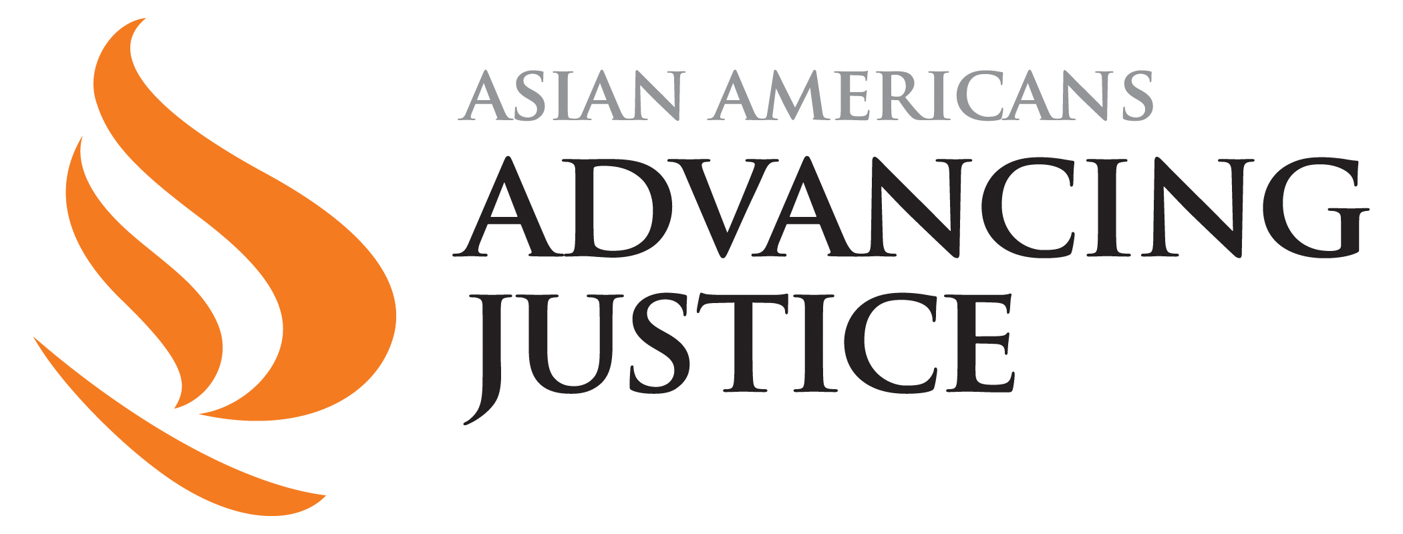



[**PBSLearningMedia.org/collection/asian-americans-pbs**](https://www.pbslearningmedia.org/collection/asian-americans-pbs/)

Major Funding for ASIAN AMERICANS is provided by Corporation for Public Broadcasting (CPB); Public Broadcasting Service (PBS); Wallace H. Coulter Foundation; Ford Foundation/JustFilms; National Endowment for the Humanities; The Freeman Foundation; The Arthur Vining Davis Foundations; Carnegie Corporation of New York; Kay Family Foundation; Long Family Foundation; Spring Wang; and California Humanities.