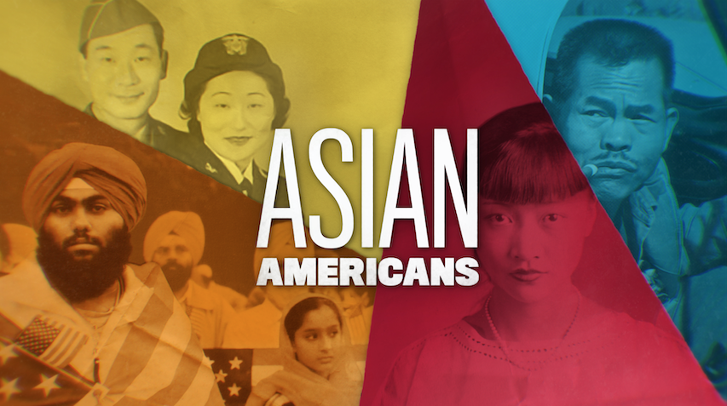

TOPIC: Southeast Asian Refugees
GRADES: 6-12

BACKGROUND ESSAY
On April 30, 1975, the fall of Saigon marked the end of the Vietnam War, with the communist government of North Vietnam taking over anti-communist South Vietnam, and unifying the country into the Socialist Republic of Vietnam. Having played a major role in the war, the U.S. government coordinated many operations to evacuate any South Vietnamese who were against North Vietnam. The U.S.’ massive bombing raids that aimed to destroy any source of supplies and weapons from North Vietnam to supporters living in the south caused widespread devastation all throughout Vietnam, Laos, and Cambodia. The destruction by bombs and chemical weapons left many wounded, traumatized, and homeless. Many Southeast Asians had fought alongside the U.S. military during the war and were in danger of retaliation by the new communist governments established in their home countries. The risk of being persecuted by these new governments was also the case for former high-level officials and others deemed the enemy by new leaders.
This resulted in a large-scale migration of nearly 130,000 Southeast Asian refugees from Vietnam, Cambodia, and Laos (including the Hmong people, an ethnic group of people without their own country) to the United States. On May 23, 1975, President Gerald Ford signed the Indochina Migration and Refugee Assistance Act into law, which categorized Vietnamese, Cambodian, Laotian, and the Hmong people as refugees to be resettled in the U.S.
Immediately following the war, thousands of people were not able to be evacuated by the U.S. because of limited resources and space, and were forced to fend for themselves. They filled boats and freighters beyond capacity, and have been referred to as the “boat people,” The refugees endured many hardships and dangers as they moved to temporary camps in other Southeast Asian countries, and many eventually made it to the U.S. Hundreds of thousands of people perished at sea. Through the resettlement program, Southeast Asian refugees were mainly relocated to poor urban areas of the U.S., where many felt isolated and were in shock. They faced widespread racism due to some Americans’ resentment and fear of refugees not being able to assimilate to the American way of life. Despite this and being traumatized from the war, they began raising families and forming communities.
Many Vietnamese refugees who grew up in the U.S. wanted to change the narrative in which the story of the Vietnam War was told. Professor and author Viet Thanh Nguyen wrote the novel The Sympathizer as a way to show a Vietnamese perspective of the war. Similarly, filmmaker Ham Tran created the film, Journey From the Fall for the same purpose and learned more about the myriad of refugee experiences by listening to the refugees he cast in the film. He wanted to capture the truth as much as possible by having those who lived through these situations play the characters of the film rather than actors.
Several laws were implemented in subsequent years to assist with the resettling of southeast Asian refugees impacted by the Vietnam War. In 1980, President Jimmy Carter signed the Refugee Act, which established the Office of Refugee Resettlement to help refugees resettle in the U.S. effectively and to become economically self-sufficient. In 1988, the American Homecoming Act allowed 23,000 mixed-blood Vietnamese children of American fathers, and 67,000 of their immediate relatives, to immigrate to the U.S. and also qualify for refugee benefits. Through the Hmong Veterans' Naturalization Act of 2000, Hmong and Laotian veterans that served for the U.S. during the Vietnam War received American citizenship. By 2010, 1.2 million southeast Asians fled to the United States.

VOCABULARY
- Communism: ideology structured upon the ideas of common ownership and the absence of social classes, money and the state
- Refugees: people who have been forced to leave their country because of war and/or they have been mistreated and victimized due to their racial or ethnic background, religion, nationality, and/or political beliefs
- Resettlement: helping people, often refugees, move from their home country to a nation willing to allow them to settle there
- Trauma: when people who have experienced terribly frightening and distressing events, leading them to emotional responses that make it difficult for them to cope with life

DISCUSSION QUESTIONS
- What are examples of how Southeast Asian refugees faced discrimination when they moved to the United States? Why were they being treated in this way?
- Why do you think the U.S. government created laws to allow so many Southeast Asian refugees into the U.S.? What does this say about the responsibility that the U.S. might have toward people abroad who have been affected by U.S. foreign policies?
- According to professor and author Viet Thanh Nguyen, what issues affected Southeast Asian refugees, like his family, when they arrived in the U.S.?
- How did the discrimination experienced by his parents lead Viet Thanh Nguyen to “write another story” for Southeast Asian refugees?
- How do Viet Thanh Nguyen and Ham Tran rehumanize the Vietnamese people in their storytelling?

ACTIVITIES
Activity 1: The Narrative of Refugees
Students will examine the different perspectives on the Vietnam War to understand dominant and counter narratives that are told about historical events. It has been more common to hear the dominant narrative of the Vietnam War of the experiences of non-Asian Americans who fought abroad. The lesser known story or the counter narrative is understanding the Vietnam War from the perspective of the North and South Vietnamese who fought during the war and the refugees who left Southeast Asia to the United States.

Review the following terms with students:
- Dominant narrative: History or story that’s repeatedly told through a dominant culture’s interests or ideologies.
- Counter narrative: History or story told from the point of view of an often marginalized or lesser known group.

Have students watch the following clips to gain an understanding of the counter narrative stories of the Vietnam War:

- “Miki Nguyen’s Story” from Last Days in Vietnam: AMERICAN EXPERIENCE
- The Vietnam War PBS documentary clips:
  - “A Great Cost”
  - “Vietnamese vs. Vietnamese”
  - “Shot Right Here”

Divide students into groups of three or four and have them answer the following questions:

- Dominant Narrative - From the “Southeast Asian Refugees” clip, look closely at how American films like Platoon and Casualties of War portrayed Southeast Asians. Consider how these films represent the dominant narrative of the Vietnam War
  - How are white American soldiers portrayed?
  - How are Vietnamese people portrayed?
  - How is each group humanized or dehumanized? Explain why.
  - What effects have these films had on Southeast Asian refugees? Why?

- Counter Narrative - Use the clips from Last Days in Vietnam and The Vietnam War to answer the questions below. From the “Southeast Asian Refugees” clip, think about how Asian Americans have contributed to providing a counter narrative of how Vietnamese people are portrayed during the Vietnam War?
  - How are Vietnamese people portrayed? How is this a more humanizing depiction?
  - Why did many Vietnamese not want to share their stories about the war until they were formally interviewed by Ham Tran?
  - What is the importance of having the stories of Southeast Asian refugees be told by southeast Asian refugees themselves?

Activity 2: Refugee laws and programs in the U.S.
Divide students into groups and assign each group to research one of the refugee-related laws and programs in the U.S.:

- Displaced Persons Act of 1948
- Refugee Relief Act of 1953
- Migration and Refugee Assistance Act 1962
- Indochina Migration and Refugee Assistance Act (1975)
- United States Refugee Act of 1980
- American Homecoming Act of 1988

Have each group answer the following questions in reference to their assigned law:
- According to the United States Citizenship and Immigration Services, who qualifies as a refugee and how can they come to the U.S.?
- What is the purpose of this law?
- From which countries did most refugees come from under this law?
- Why might it be important for the U.S. to have refugee laws and programs?

- Until late 2019, the U.S. accepted more refugees from around the world each year than all other nations combined. How has the U.S. refugee resettlement program in the U.S. changed over the years? Share source material used to answer questions.

Activity 3: Present Day Refugees
Students will compare the Southeast Asian refugee experience during the Vietnam War with the Syrian refugee experience. Since 2011, a civil war in Syria displaced over 6.8 million refugees across the world. Have students conduct research using primary and secondary sources on the Syrian refugee crisis.

Instruct students to create a T-chart and title it “Refugees from the Past and Present.” Label the left column “Syrian Refugees” and the right column “Southeast Asian Refugees.” In each column, have students answer the following questions pertaining to the different refugee population: left column for Syrian refugees and right column for Southeast Asian refugees:

- What caused the refugee crisis?
- Why did people flee?
- What has the United States and other countries been doing about the Syrian refugee crisis?

Pair students up and have them compare and contrast the southeast Asian and Syrian refugee experience.

Use the following questions to guide the class discussion:
- Based on the reasons that the U.S. accepted certain Southeast Asians as refugees, should the U.S. accept Syrian refugees?
- What factors determine the U.S. government’s decision to grant legal refugee status to a person?

FURTHER INFORMATION
- “Remembering When Southeast Asia Refugees Dominated Discussions,” NPR
- “The State of The World's Refugees 2000: Fifty Years of Humanitarian Action - Chapter 4: Flight from Indochina,” United Nations High Commissioner for Refugees (UNHCR)
- "The Devastating Impact of Deportation on Southeast Asian Americans," Southeast Asia Resource Action Center
- “Teaching about Refugees,” United Nations High Commissioner for Refugees (UNHCR)

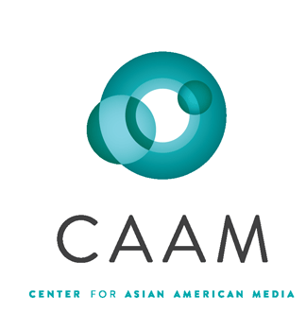
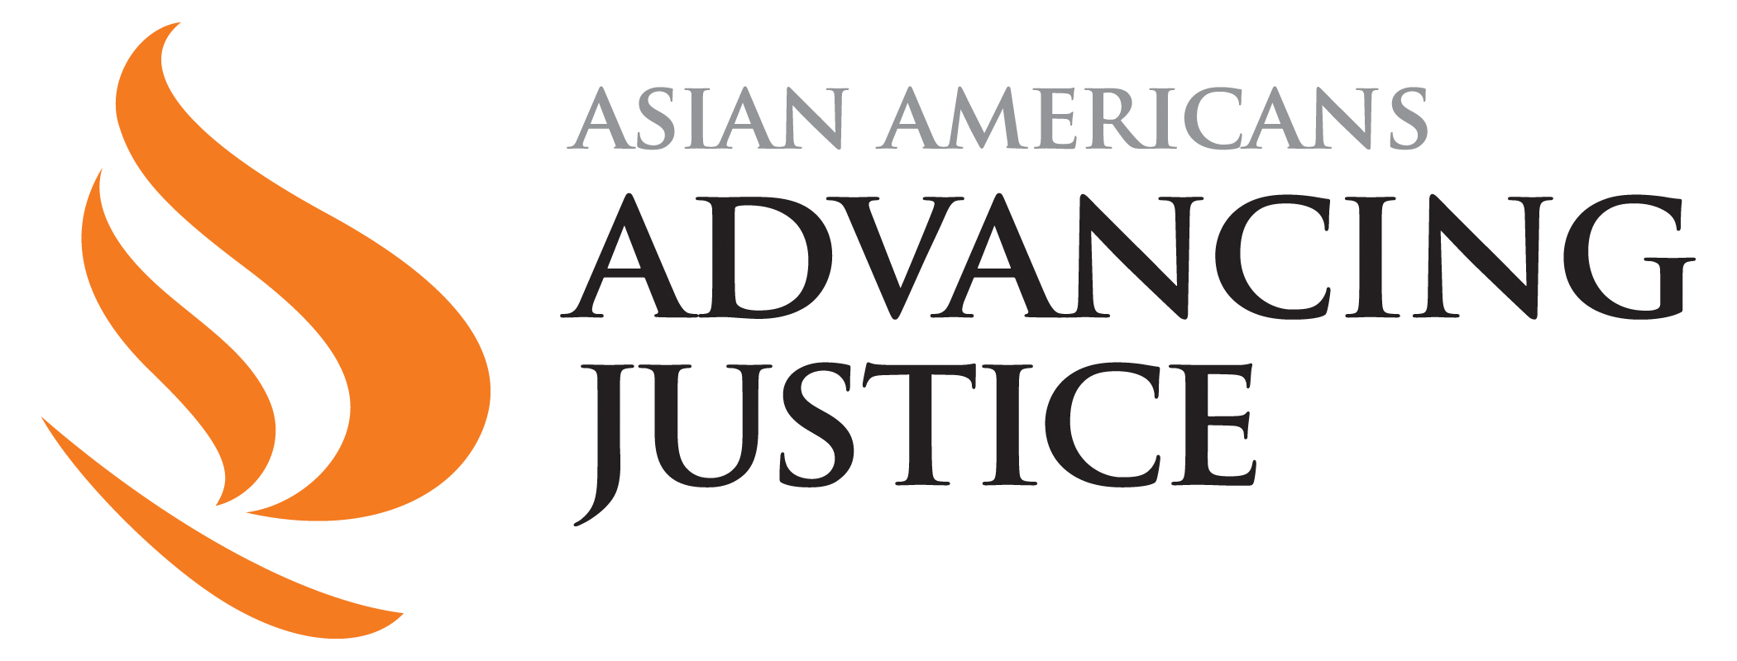

PBSLearningMedia.org/collection/asian-americans-pbs

Major funding for Asian Americans is provided by Wallace H. Coulter Foundation; Corporation for Public Broadcasting (CPB); Public Broadcasting Service (PBS); Ford Foundation/JustFilms; National Endowment for the Humanities; The Freeman Foundation; The Arthur Vining Davis Foundations; Carnegie Corporation of New York; Kay Family Foundation; Long Family Foundation; Spring Wang; and California Humanities.

