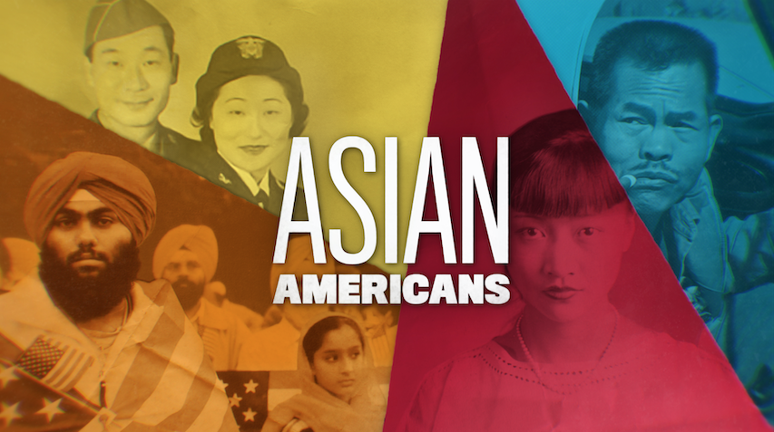

**TOPIC: Views from the Top and Bottom of Success in the Silicon Valley**

**GRADES: 7-12**

**BACKGROUND ESSAY**

Asian Americans are significant contributors to the high tech boom in California’s Silicon Valley, which began in the late twentieth century and continues today. In the 1990s, the Silicon Valley was a fertile field of innovation. Its allure attracted many college-educated professionals in the computing and technological fields. Highly-skilled Asian Americans and Asian immigrants worked to establish successful high tech startup companies—over 40 percent of them—during this period. For example, Jerry Yang co-founded Yahoo! in 1994, eventually becoming one of the largest Internet search engine companies.

Other impactful companies founded or co-founded by Asian Americans include: YouTube by Chinese American Steve Chen and Bangladeshi-German American Jawed Karim; Zoom by Chinese American Eric Yuan; LinkedIn by Vietnamese American Eric Thich Vi Ly; Fitbit by Korean American James Park; and Sun Microsystems by Indian American Vinod Khosla.

By the turn of the 21st century, the business model that began in Silicon Valley became a global phenomenon. Some Asian American entrepreneurs utilized their Asian identity and international connections to establish overseas business partnerships, leading to the globalization of the high tech industry. Their efforts helped companies based in Silicon Valley to build relationships with manufacturers in India, China, South Korea, and other Asian nations.

While some Asian American entrepreneurs were able to build lucrative companies, their success was made possible because of the labor of many lower-income Asian Americans, often in ways that were not widely acknowledged. In Silicon Valley, Asian immigrants—many refugees from Southeast Asia during the 1970s and 1980s, including the Vietnamese, Cambodian, Laotian, and Hmong—found employment as piecework laborers for high-tech companies.

Although Asian immigrant piecework laborers often lacked college degrees and earned low wages, their efforts helped to make Silicon Valley an American “success story.” Multiple viewpoints remind us that, while there may be opportunities available to some Asian Americans, not all are recipients of the wealth.

**VOCABULARY**

* **Piecework**: A job where workers are paid for the number of completed pieces produced rather than by the number of hours necessary to complete the work.
* **Start-up:** A newly formed business or company that is at the early stages of operations and is seeking funding for growth.
* **Entrepreneur:** A person that starts or manages a business or company that may be at risk to lose money if unsuccessful.

**DISCUSSION QUESTIONS**

* In what ways are the Asian American entrepreneurs during Silicon Valley’s tech boom in the 1990s similar to and different from the Chinese workers on the Transcontinental Railroad of the 1860s?
* How were Asian American entrepreneurs able to forge international business connections and thereby help to globalize the high tech industry?
* Who are the piecework laborers mentioned in the documentary? How was awareness raised about this important component of Silicon Valley’s success?
* Who are some of the Asian American entrepreneurs from Silicon Valley? How have their companies made an impact on our world today?

**ACTIVITIES**

**Activity 1: Asian American Entrepreneurs and Pieceworkers**

Students should do a one to two-page reflective writing piece that thoughtfully responds to the following writing prompt:

*While learning about the contributions of Asian Americans during the Silicon Valley high tech boom in the 1990s, why is it important to consider the stories of both entrepreneurs and piecework laborers?*

**Activity 2: The Wealth Gap of Silicon Valley**

Ask students to read these articles:

California Budget and Policy Center. “Inequality and Economic Security in Silicon Valley.” May, 2016. <https://calbudgetcenter.org/resources/inequality-economic-security-silicon-valley>

McNulty, Jennifer. “Nine in 10 Silicon Valley jobs pay less now than 20 years ago.” *University of California.edu,* October 10, 2018. <https://www.universityofcalifornia.edu/news/nine-10-silicon-valley-jobs-pay-less-now-20-years-ago>

Then, have a class discussion on:

* What are some recent income trends of those who work in Silicon Valley?
* Who has been most affected by the widening wealth gaps in Silicon Valley?
* What challenges do low-income families face in California?
* What are some solutions to shrink the wealth gaps of those in Silicon Valley?

**Activity 3: Asian American Entrepreneurs and Their Impact on the World**

Ask students to choose an Asian American entrepreneur, either someone who founded, co-founded, or played a key role in the company.

Teachers can compile a list of Asian American entrepreneurs as a basis for the research process. The list should include a range of roles, fields, and genders. The following is an example of a list that might start the conversation. Teachers should elicit students for their suggestions and crowdsource a list of entrepreneurs:

|  |  |  |
| --- | --- | --- |
| **Name** | **Company** | **Role** |
| Jerry Yang | Yahoo! | Co-Founder |
| Steve Chen and Jawed Karim | YouTube | Co-Founders |
| Eric Yuan | Zoom | Founder |
| Eric Thich Vi Ly | LinkedIn | Co-Founder |
| James Park | Fitbit | Co-Founder |
| Vinod Khosla | Sun Microsystems | Co-Founder |
| Michelle Phan | Em Cosmetics | Founder |
| Charlotte Cho | Soko Glam | Founder |
| Jason Wu | Jason Wu (fashion designer) | Founder |
| David Chang | Momofuku; Milk Bar | Founder |
| Roy Choi | Kogi BBQ truck | Founder |
| Reshma Saujani | Girls Who Code | Founder |
| Anjali Sud | Vimeo | Chief Executive Officer |
| Ellen Pao | Project Include | Co-Founder |
| Tony Hsieh | Zappos | Founder |

Teachers should then direct students to select an individual from the list and conduct research on that person and their company. Students will answer the following in a written document:

* What Asian American entrepreneur did you select, and what company did they found, co-found or play a key role in?
* What is the Asian American entrepreneur’s background: Where they were born? Did they immigrate to the United States? What was their education and other relevant experience before they founded/co-founded their company?
* What does their company do?
* How has their company impacted them and the world today?
* Did the entrepreneur’s background have an influence on their success? Why or why not?

*Extensions*:

After students have selected an entrepreneur to research, ask them to consider the variety of roles that make their entrepreneur(s)’ company functional. Beyond the founders and leadership, what jobs contribute to a company’s day-to-day work? Students can create a brainstorming cloud that generates a list of as many roles and responsibilities at a company, such as janitorial staff, budget analysts, or bus drivers who drive the workers from home to the office.

For more information, direct students to this report on “invisible” workers who support the tech industry:

“Tech’s Invisible Workforce.” *Silicon Valley Rising.* March, 2016. <https://siliconvalleyrising.org/files/TechsInvisibleWorkforce.pdf>

**FURTHER INFORMATION**

* Kochhar, Rakesh, and Anthony Cilluffo. “Income Inequality in the U.S. Is Rising Most Rapidly Among Asians.” *Pew Research Center's Social & Demographic Trends Project,* December 31, 2019. <https://www.pewsocialtrends.org/2018/07/12/income-inequality-in-the-u-s-is-rising-most-rapidly-among-asians>
* Saxenian, AnnaLee. “Silicon Valley’s New Immigrant Entrepreneurs.” *The Center for Comparative Immigration Studies,* 2000. <https://escholarship.org/content/qt88x6505q/qt88x6505q.pdf>



[**PBSLearningMedia.org/collection/asian-americans-pbs**](https://www.pbslearningmedia.org/collection/asian-americans-pbs/)

Major Funding for ASIAN AMERICANS is provided by Corporation for Public Broadcasting (CPB); Public Broadcasting Service (PBS); Wallace H. Coulter Foundation; Ford Foundation/JustFilms; National Endowment for the Humanities; The Freeman Foundation; The Arthur Vining Davis Foundations; Carnegie Corporation of New York; Kay Family Foundation; Long Family Foundation; Spring Wang; and California Humanities.