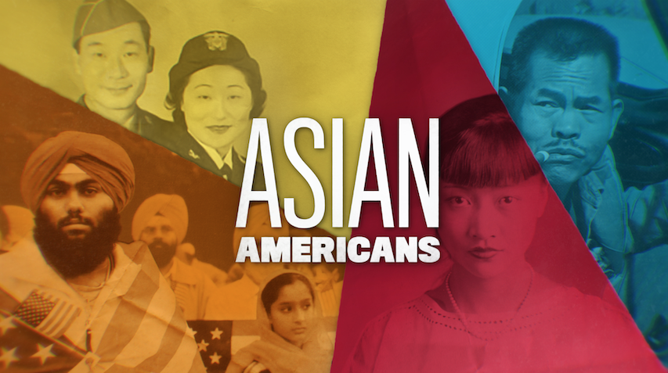

TOPIC: Asian Americans on the Big Screen: Responding to Stereotypes

GRADES: 6-12

BACKGROUND ESSAY
Asian Americans have historically been stereotyped in the United States as “foreigners,” promoted and maintained by the film industry. In Hollywood, Anna May Wong, a Chinese American actor who launched her career in the 1920s, faced many setbacks. Wong was passed over for roles intended for an Asian actor and given instead to white actors. For example, the lead female role in The Good Earth (1937)—about Chinese farmers—went to Luise Rainer instead of Wong. Rainer appeared in “yellowface,” a common practice of using stage makeup and effects on white actors so that they could “appear” as Asian. Later, Mickey Rooney in yellowface played a Japanese neighbor in Breakfast at Tiffany’s (1961). Across many of these Hollywood films, Asian males were played as scheming, weak, ignorant, and undesirable; on the other hand, Asian females were framed as exotic, cunning, and subservient.

In the 1960s, actress Beulah Quo told Hollywood executives that it is not acceptable to call Asian Americans “Chinks.” But real change has proved slow: In 2015, the hashtag #OscarsSoWhite addressed Hollywood’s widespread racial inequality in casting and production. Just one year later, a meme emerged that featured the popular Asian American actor, John Cho, in movie posters and leading roles typically reserved for white actors. Viewers turned to social media to criticize films that cast roles originally written for Asian and Asian American characters with white actors. Some of these included Matt Damon’s hero who saves China in The Great Wall (2016), Tilda Swinton as an Asian monk in Doctor Strange (2016), and Scarlett Johansson playing the lead character—originally Japanese—in Ghost in the Shell (2017).

Even with the success of Crazy Rich Asians (2018), the highest-grossing American romantic comedy in over a decade, Asian Americans continue to face obstacles on- and off-screen. Today, filmmakers and actors—like Ang Lee, George Takei, Sandra Oh, Constance Wu, Margaret Cho, John Cho, Daniel Dae Kim, Grace Park, and the Media Action Network for Asian Americans—have campaigned against such stereotyping, whitewashing, and unequal treatment in the film and television industries. These protests have stirred larger, and still ongoing, conversations about diversity and representation in the media.

VOCABULARY
- Foreigner: A person who is located outside a place or country and especially outside one's own country.
- Perpetuate: Continuing to spread or maintain a certain idea or belief.
- Stereotype: A common belief, often negative, about or attached to a particular group of people.
- “Yellowface”: The use of makeup and prosthetics by white actors to portray Asian characters.
- Yellow Peril: A term originating in Europe and the United States at the turn of the 20th century. It refers to the fear of Asian countries and Asian immigrants, whether it be a military threat from Asian nations, the economic threat of Asian Americans workers, or the threat to a white race posed by race-mixing and intermarriage.
- Whitewashing: The casting or rewriting of Asian roles for white actors.

DISCUSSION QUESTIONS
- What are some common images of Asian Americans on TV and in movies today? How did the speakers in the clip feel about seeing these images as they were growing up?
- What stereotypes of Asian and Asian Americans appeared in Hollywood films?
- How might seeing positive or negative images of a group affect you, especially if you are part of the group being portrayed?

ACTIVITIES
Activity 1: Responding to Stereotypes
Start the activity by explaining that students will be thinking about identity, or the many categories that capture our relationships to our families, interests, experiences, and society. Start the activity by saying that sometimes the way that we see ourselves may be different from how others see us.

Ask students to create this chart on a piece of paper:

How I See Myself | How Others See Me

In the left column, direct students to take a few minutes to reflect on how they “see themselves.” Here is a list of descriptions that they might consider:
- Personal characteristics
- Name
- Racial or ethnic identity
- Gender
- Abilities
- Sexuality
- Immigration status
- Hobbies
- Activities
- Place or home country
- Language
- Family

Then, ask the students to consider how others see them. Give them a few starting points: When others look at you, what do they see? How might they judge you? What labels might they put on you? In the left column, students should write the stereotypes, assessments, and assumptions that people may make about them.

Finally, ask all of the students to reflect aloud as a group on these questions:
- What difficulties have emerged when others view you differently than you view yourself?
- What is so bad or wrong about stereotyping? Why does it need to stop?
- What do you think a person can do to help reduce it?

Activity 2: Hollywood’s Role in Stereotyping
After watching the clip and reviewing the vocabulary, students will dig deep into tactics used by the film industry to depict people of color. On big pieces of chart paper, write the following words:
  - Yellowface
  - Brownface
  - Blackface
  - Whitewashing
  - Perpetual foreigner

Tape the pieces of paper to walls or place them on separate tables. Pass out different colored markers. Let students know that they will be doing a “silent conversation” on these big pieces of paper. They should write any commentary, connections, questions, or examples that come to their mind about the word. Their conversation can stray or move in many directions. Emphasize that conversation should happen on the paper and said not aloud.

Direct students to pair up or work in groups of three on one big paper. Allot 5 minutes for their silent conversation.

After the time is up, direct students to freely move around the room. Again, in silence, they should look at other students’ big papers and add their own commentary. Give students another 5-7 minutes to do this portion of the activity.

Finally, direct students to return to their original paper and word. They can now talk aloud. Tell them to see what has been added to their initial conversation.

Gather students as a whole class to debrief their silent conversation Ask: What did you learn from having a silent conversation about these words?

Optional Extension Activity:
Considering Hollywood’s history of racial inequality, find other examples of yellowface and whitewashing in film or media and create a list in class.

Create an infographic, protest poster, or video that presents the problem of whitewashing in the media and suggests how public audiences can respond to this problem.

FURTHER INFORMATION
Smith, Stacy L., Marc Choueiti, Katherine Pieper, Kevin Yao, Ariana Case and Angel Choi. “Inequality in 1,200 Popular Films: Examining Portrayals of Gender, Race/Ethnicity, LGBTQ & Disability from 2007 to 2018.” USC Annenberg School for Communication and Journalism, September 2019.

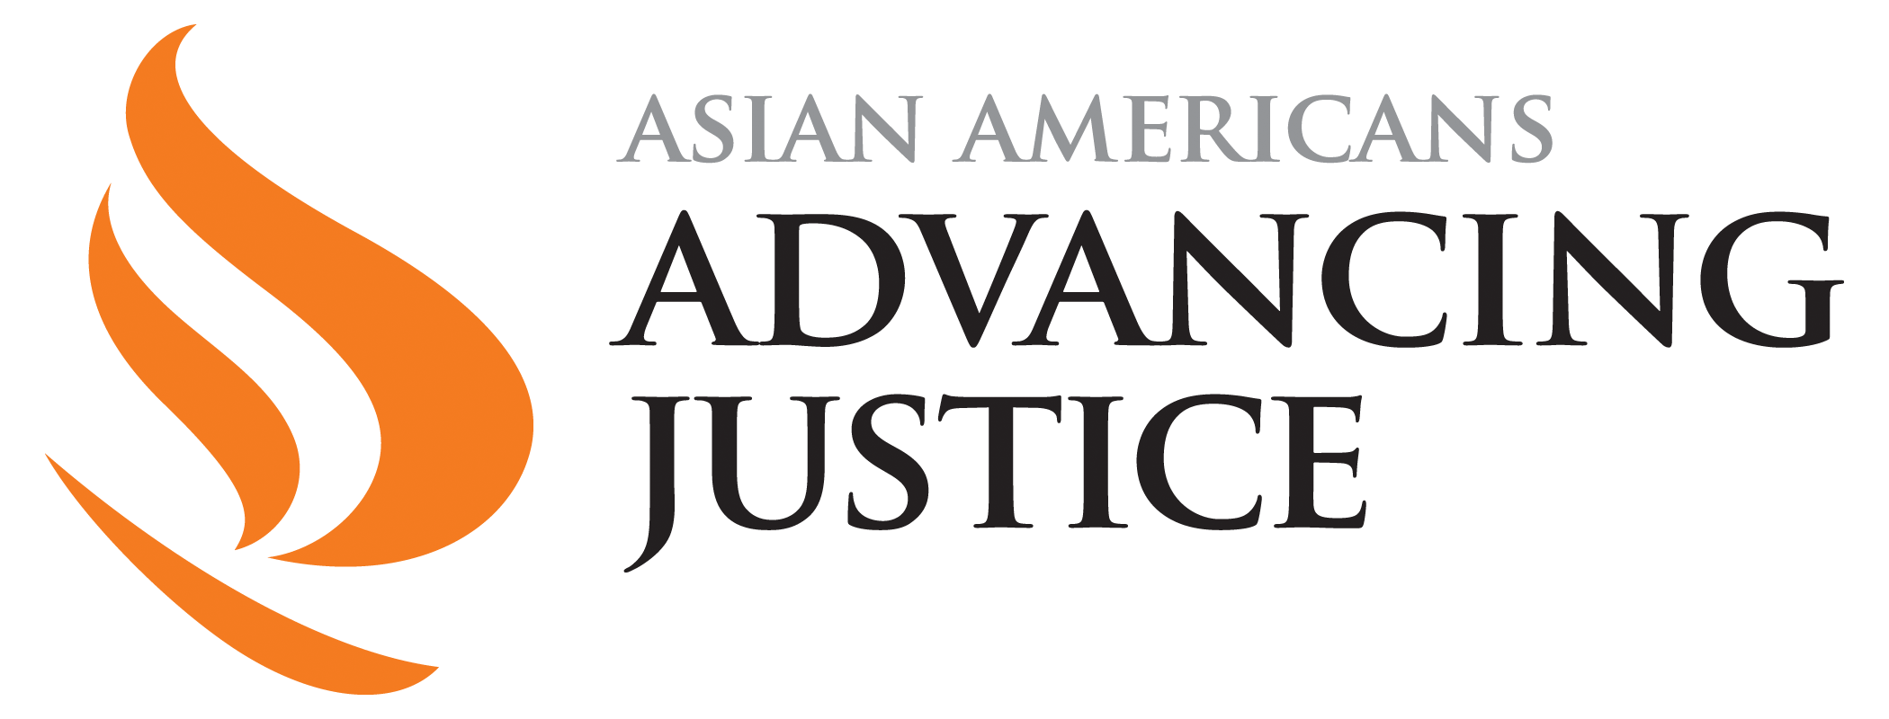

PBSLearningMedia.org/collection/asian-americans-pbs

Major funding for Asian Americans is provided by Wallace H. Coulter Foundation; Corporation for Public Broadcasting (CPB); Public Broadcasting Service (PBS); Ford Foundation/JustFilms; National Endowment for the Humanities; The Freeman Foundation; The Arthur Vining Davis Foundations; Carnegie Corporation of New York; Kay Family Foundation; Long Family Foundation; Spring Wang; and California Humanities.

